Project Design Phase-II
Data Flow Diagram & User Stories

Date | 3 February 2026
Team ID | LTVIP2026TMIDS24222
Project Name | Flavour Fusion: AI-Driven Recipe Blogging
Maximum Marks | 4 Marks

Data Flow Diagrams:
A Data Flow Diagram (DFD) is a traditional visual representation of the information flows within a system. A neat and clear DFD can depict the right amount of the system requirement graphically. It shows how data enters and leaves the system, what changes the information, and where data is stored.
DFD Level 0 (Industry Standard)
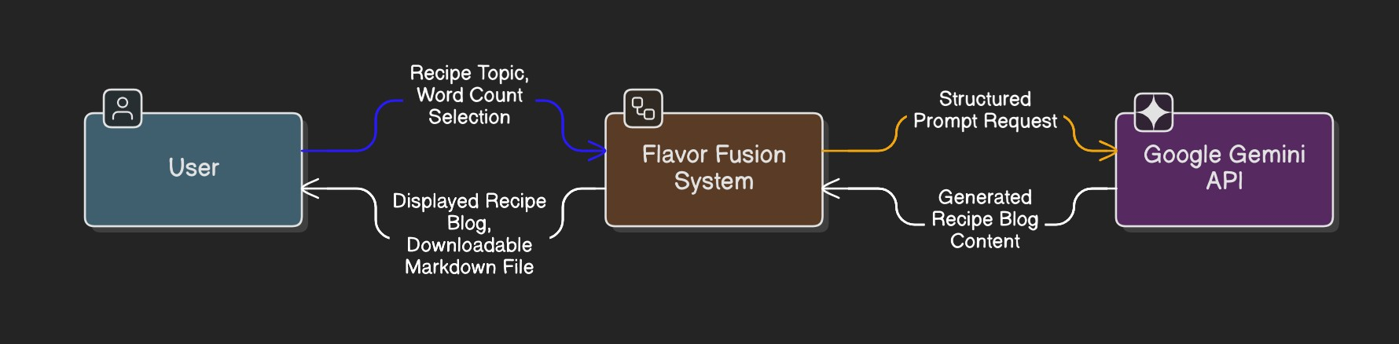
DFD Level 1 (Industry Standard)

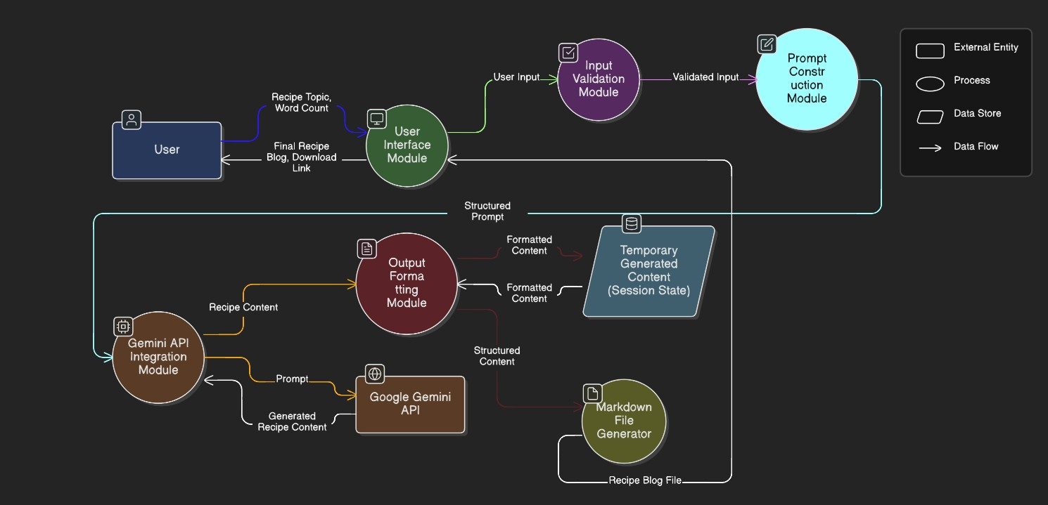
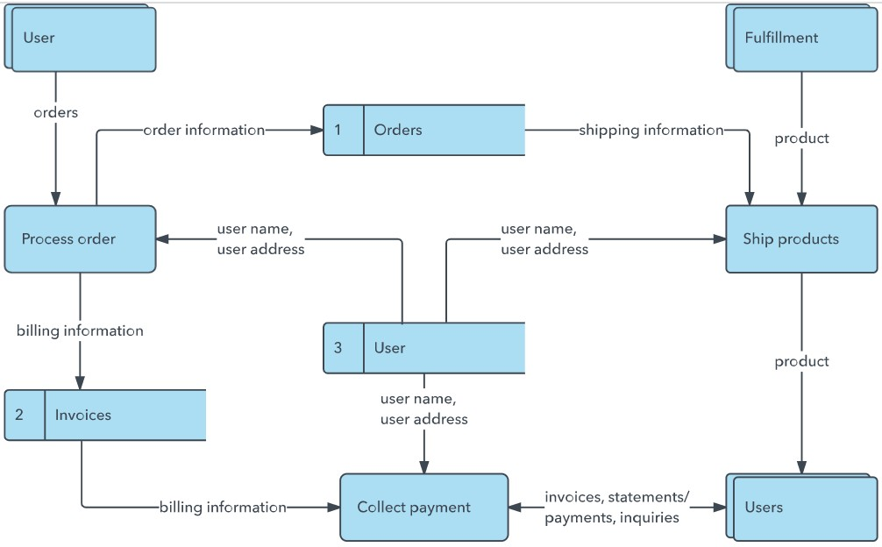
Example: 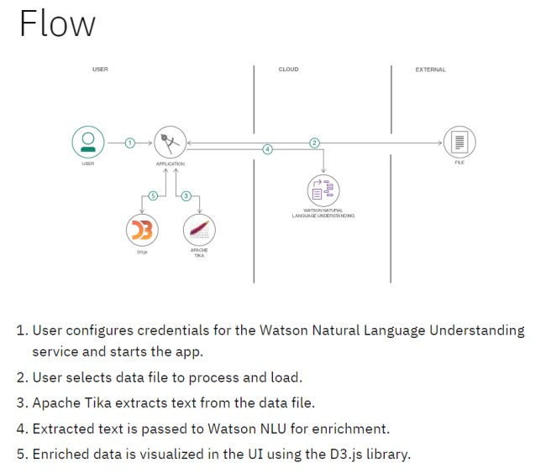

User Stories
Use the below template to list all the user stories for the product.

User Type | Functional  Requirement  (Epic) | User Story Number | User Story / Task | Acceptance Criteria | Priority | Release
Customer (Web  User) | Enter Recipe  Topic | USN-1 | As a user, I can enter a recipe topic so that I can generate a recipe blog based on it. | The system accepts topic input and displays it correctly before generation. | High | Sprint-1
Customer (Web  User) | Select Word  Count | USN-2 | As a user, I can select the desired word count (100–2000 words) for the recipe blog. | Generated blog approximately matches selected word count range. | High | Sprint-1
Customer (Web  User) | AI Recipe  Generation | USN-3 | As a user, I can generate a structured recipe blog using AI. | The system generates title, introduction, ingredients, and instructions. | High | Sprint-1
Customer (Web  User) | Loading  Experience | USN-4 | As a user, I can see a programming joke while the recipe is being generated. | A random joke is displayed during the loading state. | Medium | Sprint-1
Customer (Web  User) | Display  Generated Blog | USN-5 | As a user, I can view the generated recipe blog directly on the screen. | Generated content appears clearly formatted in the UI. | High | Sprint-1
Customer (Web  User) | Download Blog | USN-6 | As a user, I can download the generated recipe blog as a Markdown (.md) file. | Clicking download provides a valid .md file containing generated content. | High | Sprint-1
Customer (Web  User) | Input Validation | USN-7 | As a user, I am prevented from generating a recipe if the topic field is empty. | System shows validation message and blocks generation. | High | Sprint-1
Customer (Web  User) | Regenerate  Recipe | USN-8 | As a user, I can generate a new version of the recipe by changing topic or word count. | New output replaces previous result without system error. | Medium | Sprint-2
System | Gemini API  Integration | USN-9 | As the system, I must send a structured prompt to Google Gemini API and receive a response. | API request succeeds and returns recipe content. | High | Sprint-1
System | Error Handling | USN-10 | As a user, I receive an error message if the AI generation fails. | System displays clear error message without crashing. | Medium | Sprint-2

